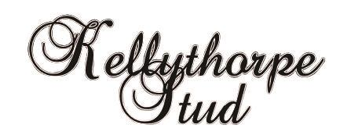

Kellythorpe Leading Breeder of the Year Awards

Section | Breeder | Prefix
HUNTER | BRENDAN CORCORAN
SHOW HORSE | SHARON HOWARTH | CARRHOUSE
COLOURED | CAROLINE HAMILTON | LOSTOCK
HUNTER PONY | MESDAMES J & V STEPHENS | ANNANDALE
SHOW PONY | MRS A M SMALLEY & MISS C J SMALLEY | BARKWAY
ARAB | MR C LOWE & MRS J LOWE
MINIATURE | LISA TAYLOR
CONNEMARA | MR C RATTIGAN | CARROWNURLAUR
DALES | MRS J PENNELL | NIPNA
EXMOOR | MRS J WEBB
FELL | MRS I POTTER | GREENHOLME
HIGHLAND | KATE LAWSON | LOCHLANDS
NEWFOREST | MR & MRS ALEX HUMBLE
SHETLAND | MR JULIAN WALTERS | SHARPTOR
WELSH A | MR S ANDERSON | THISTLEDOWN
WELSH B | MESDAMES J & V STEPHENS | ANNANDALE
WELSH C | MR S ANDERSON | THISTLEDOWN
WELSH D | P J GRAY | THORNEYSIDE

